[click here](http://go.ncsu.edu/edgecombestrawberryjam)

“NC State University and N.C. A&T State University are collectively committed to positive action to secure equal opportunity and prohibit discrimination and harassment regardless of age, color, disability, family and marital status, gender identity, genetic information, national origin, political beliefs, race, religion, sex (including pregnancy), sexual orientation and veteran status. NC State, N.C. A&T, U.S. Department of Agriculture, and local governments cooperating.”

“Accommodation requests related to a disability should be made by April 13, 2018 to Regina Moseley, 252-641-7821 or regina_moseley@ncsu.edu”

**Date: Tuesday, April 24, 2018**

**Time: 5:30pm -8:00pm**

**Place: Edgecombe Cooperative Extension Family & Consumer Science Lab**

**201 St. Andrew St**

**Tarboro, NC**

**Cost: $10.00**

**Register by: Friday, April 20, 2018**

**Call 252-641-7821 or** [**Click here**](http://go.ncsu.edu/edgecombestrawberryjam) **to register**

**Registration fee must be paid by Friday, April 20, 2018**



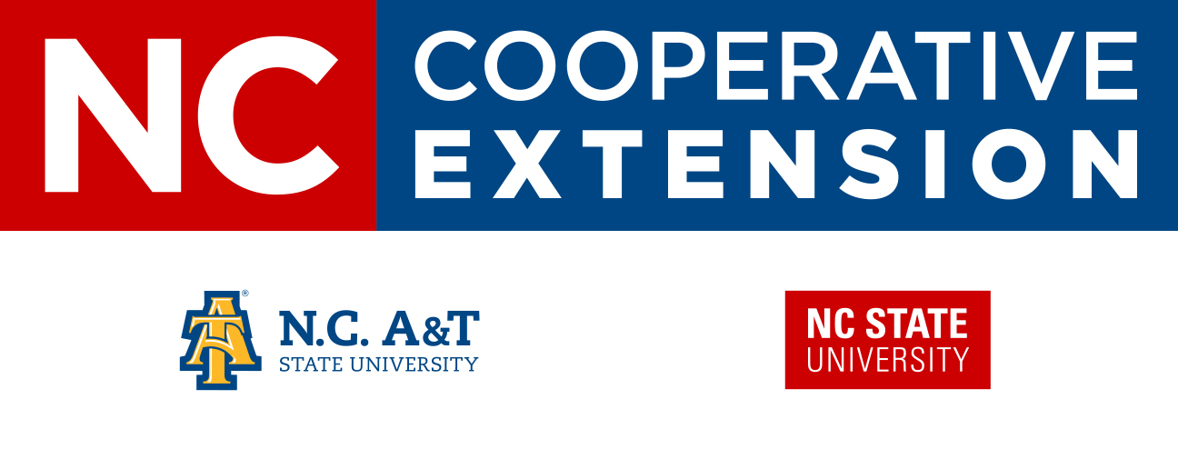

**Strawberry Jam Workshop**

**Participants will learn how to properly preserve strawberries by making strawberry jam. You will sample and take home some of your own jam.**

